Spirituality in Education in the United Kingdom
Proposal for strategy development and next steps

Content document
1. Context
2. Need and opportunity Spiritual Education
3. Meshworking as multiple stakeholders approach
4. Use 7 steps Meshwork Process
5. Multi stakeholder group Composition
6. Scope of the quest
7. Next actions
8. Budget

1. Context

Lord Stone has asked Anne-Marie Voorhoeve of The Hague Center for Global Governance, Innovation & Emergence to assist with bringing together relevant parties. In education and certainly in spiritual education many stakeholders are involved, with different roles to play. The Hague Center exists to help align necessary resources for the current human and planetary transition. Anne-Marie’s focus is on international societal challenges whose complexity requires collaboration between multiple stakeholders. The Hague Center provides insight into the current condition, and co-design and facilitate transition processes towards better futures. We work closely with UK based Gaiasoft with Morel Fourman and team, that works with consultancies, governments and global agencies to deliver policies and plans through thought leadership, innovation, implementation support and configurable platforms. Janice Dolley has agreed to guide us, given her well respected and extensive knowledge and experience in the educational field in the UK and beyond.
What happened up till now
- Report of the Commission on Education “Religion and World Views: The way Forward”
- Dec 6th 2018 - Hansard, speech of Lord Stone of Blackheath at the House of Lords in debate of Lord Alderdice on Religious Education
- Nov 2018 and Jan Feb March 2019 - Unity Conference and follow up meetings
- April 4th 2019 - a dedicated meeting at the House of Lords on Spirituality and Education
- Ongoing - conversations in the field
- Ongoing - sharings through emails

2. Need and opportunity Spiritual Education
The Draft, new, Ofsted Framework of Inspection has raised the importance of developing children spiritually to a level of significance unseen before. The time therefore, is perfect for like-minded individuals and organisations to work together and to move from the ‘knowledge for survival’ to ‘know to grow.’ Spiritual development is not unique to any one faith. Manifestations of spirituality can appear beyond religion in response to, for example, meditation, the arts, nature and science. How might we gather significant support around these ideas to persuade the Government to include in the teaching in schools in the UK:
- that there is something greater than one’s habitual self
- that all humans can experience this
- and that when one does, a feeling joy and compassion for all beings for all time, can enable one to find one’s passion and purpose.

The Education Act 2002 requires schools, as part of a broad and balanced curriculum, to promote the spiritual, moral, cultural, mental and physical development of pupils at the school and of society. The problem is that although spiritual development has been on the statute books for many years, schools don’t know how to do this effectively.
The question: How can spiritual development in education practically be incorporated now across the UK Educational system?
We have been meeting with many people following the debate on ‘Religious Education’ and in general there is an agreement on a need for a way to develop a combined package that would transform the Religious Education curriculum and have it include Spiritual Education.
Children in education – for their development through life – besides preparing them for career – should be enabled to access experience of something greater than their habitual selves. There is a need to shift the focus in schools
• from learning to becoming,
• from transmission (of knowledge) to transformation (of being).

3. Meshworking as multiple stakeholders approach

Using a Meshwork process can serve the design and emergent development of answers to the calling question around Spirituality in Education put out here. In the experience of The Hague Center and Gaiasoft, it has become clear that movements of social change in the process of upscaling, follow the same phasing which can be relevant for the quest in education:
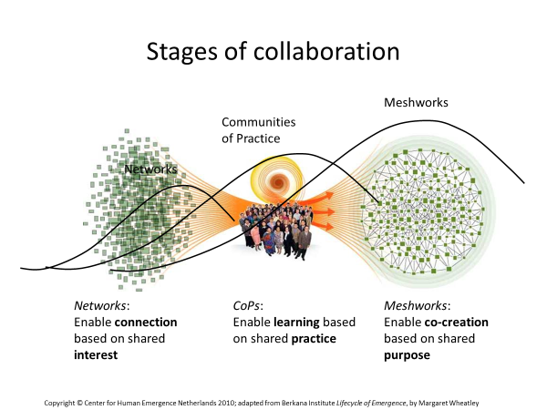

- Phase 1: Networks. In the first phase, likeminded people find each other in networks. Often with an underlying self interest, a network offers opportunities to promote the realization of individual goals in one or more areas of life.
- Phase 2: Communities of Practice (CoP). A community of practice can evolve when a network develops capacities to learn, where people trust each other, gradually open up, share their dilemmas, and learn from each other. They start to participate, not only for themselves, but also to help others. In a community of practice, knowledge is shared and eventually brought up to a level of standardization that makes it available for even broader use.

- Phase 3: Systems of Influence. The third phase appears not to be predictable. Suddenly a new system emerges into life which has a power and influence of its own. In this phase, methods developed in the CoPs become standards, and people and organisations from different sectors of society adopt the new ways of working without much resistance. (Ref Berkana Institute, THC, Gaiasoft)

Meshwork, Network & Community of Practice
Meshworking is designed to intentionally develop, speed and scale up the transition into systems of influence that serve the greater good. A Meshwork differs from a network in a number of aspects. In a network, the individual participant and his or her goals is in the center of it all. Functions of the network can be finding a principal or client, and getting new knowledge or experience. In a Meshwork, however, the self-interest of the individual is aligned with the overarching goal of the Meshwork. Participants put themselves in service of this broader goal, and at the same time participants bring the best of themselves to the process. This creates a situation in which they can also serve their own interests. On top of that, a broader goal provides a direction to initiatives, and lets individual participants perceive what piece of the puzzle they are holding.
In our experience the level of consciousness and higher purpose alignment of the participants and parties involved, clearly influence the time needed to move through the different phases.

4. Use 7 steps Meshwork Process
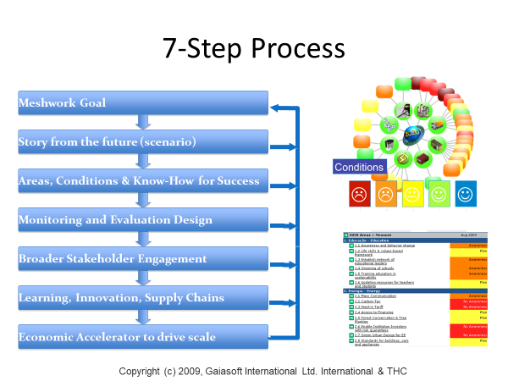
7 steps Meshwork process is given below. We advise to focus first on steps 1, 2 and 3: Goal setting including working principles to commit to, visioning – finding direction, and defining areas and conditions for success. Our purpose would be to identify collectively what to focus on now for breakthrough to happen in this quest. In the design of the processes of the steps, the above mentioned three phases (networking, community of practise, system of influence/ meshwork) are taken into account.
5. Multi stakeholder group composition

The steps 1-3 in the Meshwork process can be done by one group, with different groups, and can also be woven together. In conversations in preparing for this strategy document, the following has been mentioned about with whom to collaborate and a decision has not been yet made:
- Continue with group of April with a few more added (15 or so practitioners and experts)
- Select a small conscious group for intensive high level design and vision (around 8)
- Bring together a larger multi stakeholder group and do a facilitated meshwork process.

The practice of the Adizes School of Management of CAPI – Coalescing Authority, Power and Influence is an important part of Meshworking. It is a strategic choice how much who is included when and in what parts of the process. In general it is wise to have the voices of all the stakeholders that are in the field in the room. It can also be a strategic choice not to do this from the start. In that case it is often instrumental to make sure there are participants present who are informed about the parties missing.

Given the nature of the challenge here in education, we advise for participants in the first phase to be chosen based on their level of consciousness and commitment to spirituality in education that serves all.

6. Scope of the quest

Our goal will be to develop an approach that will be effective in the rather recent future.
To be decided is whether the focus is to choose for a top down approach, a bottom up (gradual) approach in which we design a program, start to introduce it to 10 schools, monitor, learn and evaluate, improve and expand, then scale (then 50 then 100 and so on).
Is focus on the UK or on the Commonwealth?

4D Mapping and energetic architecture

THC supports the process to get clarity on the stakeholders, order and scope through specifically designed and facilitated conversations and by using our practice of 4D Mapping, that gives (more) access to the collective intelligence, and which includes the use of value mapping with spiral dynamics integral SDi and Systemic Constellation Work.
THC can offer the development of energetic architecture that can serve the process, using the ECOintention practice of working.

7. Next actions

- Alignment on approach, team roles and budget allocation to get started.
- Clarity on certain choices that still need to be made. Using process of 4D Mapping, which can include choice of group composition in first phase. This can be done through zoom. Fix date for that with THC, Diana Claire Douglas and team.
- Develop next iteration of plan of action including outcomes of Systemic Constellation Work and if appropriate ECOintention Start scan.
- Define ways of working and budget in core team.
- Fix dates and select and inform participants (proposing September and November 2019 for gathering).
- Inform those who need to be updated on status quo and next steps, including the April 4th group.

8. Budget

Given the complexity of the issue, time and resources are needed to prepare a plan of action and a possible high level meeting at the House of Lords in September or November 2019. Anne-Marie offered for THC to take this forward for £10,000 (ex vat), plus an additional travel budget for a small group of people we feel are essential to join and may need support to come to the UK (including herself). To give some indication for next steps, this amount is approximately 10% of the budget needed to develop a Meshwork Plan of Action with multiple stakeholders. It could be helpful to have a provisory view on this potential budget (£90,000) at the meeting in September 2019.

Anne-Marie Voorhoeve, 21 June 2019
anne-marie@thehaguecenter.org
mobile +31 628550634

